KOSIMOVA ODINA MASHRABOVNA,

Andijan Specialized Art Boarding School under
The Academy of Arts of Uzbekistan,
Fine arts teacher
Izbaskan district of Andijan region
Turtkul village, 25 Navoi Street

KAMOLIDDIN BEHZOD - THE GREATEST MINIATURE ARTIST OF THE EAST

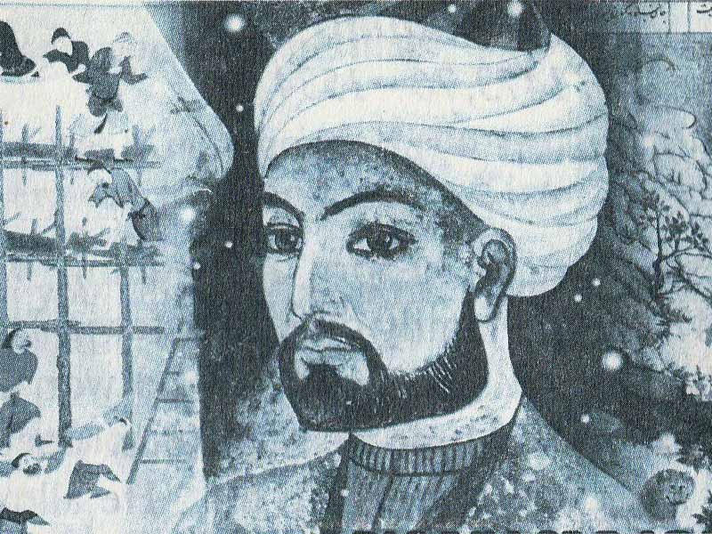
Kamoliddin Behzod, a brilliant representative of the Renaissance and a student of Alisher Navoi, a great painter, and miniature artist, was born in 1455 in Herat to a poor family.
He lost his parents as a child and grew up under the tutelage of the famous artist Mirak Nakkosh. Young Behzod diligently learned the secrets of carving from him. Behzod's talent was growing day by day due to his inquisitiveness, intelligence, and diligence. He soon became famous as an artist in Herat.
Figure 1. Kamoliddin Behzod
In 1512, he went to Tabriz, where he spent 25 years of his life continuing his creative work. Nevertheless, he returned to his hometown of Herat and later died there in 1537.
Kamoliddin Behzod is a historical figure who has left a rich legacy to his descendants. Today, more than 30 of his works and various miniatures have survived. He was able to create the images of Hussein Boykaro, Abdurakhman Jami and Shaibanikhan with great skill. Nevertheless, more than 40 miniatures depicting Hussein Bayqara’s meetings and drawings on the works of art of various scholars have brought him great success in both the East and the West.
Another contribution to the development of the arts was the establishment of a school named after Behzod.
Behzod has left an indelible mark on history, and his creative work is still revered to this day. It should be noted that his artistic heritage still poses challenges for researchers, both in terms of attributes and in terms of restoring its creative evolution. There is only one manuscript of his signed miniatures - the poet Saadi’s “Buston,” which is now housed in the Cairo National Library. The manuscript was created for the Hussein Baykaro Library, which contained four miniatures signed by Behzod. Traces of his signature were also found on the front of the book.
Figure 2. Portrait of Shaibanikhan. 1507. U.S., Metropolitan Museum
The date of the memoir written by Sultan Ali Mashhadi is 1488 (but in two miniatures another date is given - 1489). However, there are some researchers who doubt the authenticity of the signatures. Miniatures of the remaining manuscripts are presented basis on comparative analysis with the possibility of creating different levels of confidence in the method of Behzod drawing.
Thumbnails of these manuscripts:
- "Zafarnama" ("Book of Victory", Sharafuddin Ali Yazdi), dedicated to Hussein Baykar, it was drawn between 1467 and 1480. (Baltimore, Herat Library);
- "Khamsa" by Badi ul-Zaman, son of Alisher Navoi, dedicated to Sultan Hussein Bayqara, (1485, the manuscript is divided into two parts, one in Oxford, the Bodleian Library, Manchester);
- Poet Attor's "Mantiq ut-Tair" ("The Conversation of Birds"), (1486, New York, Metropolitan. Museum of Art);
- "Gulistan" (flower garden) Saadi (1486, personal collection);
- "Khamsa" by the poet Nizami, drawn in 1495-96, (London, British Library);
- Nizami’s Hamsa, a copy of 1442, but with miniatures from the 1490s added, (London, British Library);
- The Battle of Timur and the Sultan of Egypt. "Triumph of the Timurids". 1528-1529 The Gulistan Palace Library is dedicated to works such as Tehran.
Although Behzod’s name appears at the beginning of the manuscript, modern scholars doubt that the miniatures belonged to him. This is evidenced by their style and the fact that so far Behzod is old and can only carry out the process of illustration.
There are a total of seven manuscripts, three of which were developed in 1495-1496 by Nizami's "Zafarnoma", "Gulistan" and "Khamsa". The paintings contain inscriptions left by the Mughal emperor Jahangir (who ruled from 1605-1627), who was an amateur and devotee. In the notes, he tells Behzod that he gave all the miniatures called Zafarnoma, sixteen of Nizami's twenty-one Hamsa miniatures. Most modern scholars share Jahangir’s view of the Zafarnoma manuscript, but are sceptical of Nizami’s Hamsa, as his miniatures also belong to Mirek, Abd-Razzak, and Qasim Ali. One of them was Behzod’s teacher, the other two were his followers, so it is very difficult to distinguish their hand from Behzod. These three manuscripts in one way or another served as a source of inspiration for the artists of the Mongol court.
Figure 3. Majnun watches Nawfal's battle with the Layla tribe. Nizami. "Hamsa." 1442-1443 y. London. British Library
There are also many separate paintings by Behzod that have spread around the world, but their authorship is questionable. Discussions of Behzod’s artistic style will focus on Saadi’s “Bustan” miniatures in Cairo. These miniatures are the starting point for understanding his work. In the martial genre, Behzod created new iconographic schemes, in which, despite the intensity of the battles depicted, the balance of composition and colour scheme reaches the level of oriental decorative illusion, pleasing and soothing to the eye, but not turning into colour.
Figure 4. Harun al-Rashid is in the bathroom. Miniature. Nizami. “Khamsa” 1495-1496y. London. British Library.
Its compositional solutions are characterized by balance and harmony. Until the time of Behzod’s creation, it was almost impossible to find another Persian artist who arranged human figures and other compositional elements with such impeccable taste and sense of proportion. He guided the line wonderfully, so his figures stand out with a sense of movement. Also, Behzod has achieved portrait resemblance in depicting people, so in many miniatures, researchers find repetitive personalities, such as Sultan Hussein Baykaro. It is also recognized for being one of the first to convey a different skin colour, as it does in humans.
Figure 5. The battle of Timurid and Egyptian sultans."Timurid Triumph" 1528-1529 Gulistan Palace Library. Texron.
In particular, many authors point out that Behzod likes to add real-life events that are not directly related to the plot to his miniatures for animation and diversification. They also emphasize Behzod’s sense of humour, which is often evident in his miniatures. An example of this is the miniature "Harun al-Rashid in the bathroom", based on the famous Caliph of Baghdad Harun al-Rashid and the barber. In the miniature, you can see a royal crown placed on the clothes removed in the bathroom. Behzod had many followers and disciples. Among his most talented followers are Qasim Ali, Mir Seyid Ali, Aga Mirek and Muzaffar Ali. Behzod's art has long resonated and continues to influence Central Asian (Bukhara, Samarkand), Safavid, and Mongol paintings.
Figure 6. A miniature of Nizami's hamsa. "Iskander and the Seven Wise Men." 1495-1496 y. London. British Library
As a logical continuation of the reforms being carried out by the head of our state, the 565th anniversary of the birth of the artist and painter Kamoliddin Behzod (1455-1535) was widely celebrated in Uzbekistan in October 2020. To immortalize his memory, one of the streets in Tashkent was named after him. The great artist's birthday was also celebrated at the Andijan specialized art boarding school. The school administration organized various competitions and creative exhibitions among teachers and students. A sculpture of Kamoliddin Behzod was created by the school's sculptor teachers and placed in the yard of the boarding school. Creative students and teachers were duly encouraged.
The creative exhibition "We are the followers of Kamoliddin Behzod", organized by the students of the 7th grade of the school, attracted the attention of all and they were duly encouraged.
I believe that such active students will grow up to be as inquisitive and creative as Kamoliddin Behzod in the future.
The wide range of such events is reflected in the resolution of President Shavkat Mirziyoyev dated April 21, No. PD-4688 "On measures to further increase the efficiency of the fine and applied arts."
It is also planned to give a modern look to the avenue of the Museum of Oriental Miniature Art named after Kamoliddin Behzod, and in 2022 to illuminate the bronze statue of Kamoliddin Behzod located on its territory.
Starting from the 2020-2021 academic year, a state scholarship named after Kamoliddin Behzod has been established for university students studying in the field of "Fine, Applied Arts and Design".
A documentary film about Kamoliddin Behzod is planned to be produced and shown on central TV channels by October this year. Besides, the catalogue "Modern Miniature of Uzbekistan" will be published.
According to the resolution, the Academy of Arts of Uzbekistan will host a centre for retraining and advanced training of teachers and specialists in the field of art education, an additional educational building and a modern information and library centre in the vicinity of the main building of the National Institute of Art and Design named after Kamoliddin Behzod. Capital investment required for construction works.
Besides, the commissioning of measures to strengthen the material and technical base and create the necessary conditions for students of specialized art schools and boarding schools in the system of the Academy of Arts until September 1, 2022, is a vivid example of respect for such historical figures in our country.

References:

- http://e-tarix.uz/shaxslar/
- https://arboblar.uz/
- http://ferlibrary.uz/bezod_kamoliddin
- http://myday.uz/uz/muzei

